Summer Camp Rates and Information
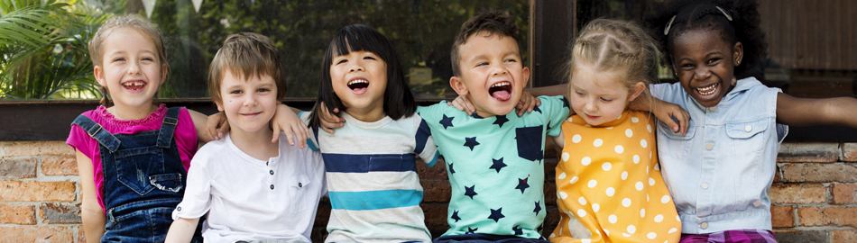
Broward County Public Schools (BCPS) offers 118 summer camp programs at 107 schools.
Summer camp programs may be operated by the school or a contracted provider.
- Summer camp program hours and fees vary by location.
- Rates vary due to program length and funding source.
- For the full list of schools with summer camp programs, visit the Before and After School Child Care website at browardschools.com/bascc, and select “Summer Camp Locations & Application”.
Please visit the school’s website or contact the school’s childcare supervisor for more specific and detailed information.
See examples of fees and discounts below.
EXAMPLE
A Typical School Board Operated (SBO) Fee-Based Summer Camp Program
Hours | 10.5 hours per day, Monday - Friday
Registration Fee | $30
Weekly Payment Periods | Only pay for the weeks your child attends,  up to 8 weeks
Weekly Pay Period Rate | $184
8-Week Summer Total | $1,398
Private providers may charge up to 20% more than SBO programs.
Programs operating less hours per day have lower pay period and summer rates.

DISCOUNTS
- All providers offer a 5% discount to families with two or more children attending the same program. Families are charged the full fee for the first child; additional children receive the 5% discount.
- BCPS employees are offered a 5% discount.
- Limited tuition scholarships are available at most locations.

